**J24 Western Championships 2019**

**Notice of Race**

**5th and 6th of October**

**Lough Ree Yacht Club**

1. **Organising authority;**
   1. The Organising Authority (OA) is Lough Ree Yacht Club).
2. **Rules;**
   1. The regatta will be governed by the rules as defined in The Racing Rules of Sailing (RRS) 2017 - 2020.
   2. The prescriptions of Irish Sailing will apply.
   3. The rules of the International J/24 Class will apply. In particular competitors should note,
   4. Class Rule C.1.1, changing rule 42 (prohibiting hanging off mast or shrouds to promote a roll tack or gybe, and allowing all parts of a main-sheet to be pulled simultaneously)
   5. Class Rule C 2.1 Crew Limitations (See also SI 20.1)
   6. Class Rule C.2.2, changing rule 49 (regulating crew position outside the upper lifeline) will apply.
   7. See also SI 20.3 regarding the use of spare spinnakers.
3. **Radio Communications:**
   1. Except in an emergency, a boat shall not make voice or data transmission and shall not receive voice or data communication that is not available to all boats. This shall apply from the time she leaves her mooring for the first race of the day until racing for the day is complete.
   2. The race committee may choose to make VHF radio communications to the fleet on a channel to be announced in the sailing instructions. It is strongly encouraged that each boat has a VHF radio on board capable of receiving these communications.
4. **Advertising;**
   * 1. World Sailing Regulation 20 will apply.
5. **Eligibility & Entry;**
   1. The event is open to boats of the International J/24 class whose helm or registered owner is a member of a National J/24 Class Association recognised by the International J/24 Class Association.
6. **Registration.** 
   * 1. Event entry forms will be available at on line & at the Event Race Office.
     2. National J/24 Class Association Membership Forms will also be available at the Event Race Office on Friday 4th October from 17:00.
7. **Entry Fee**.
   * 1. Class Registration: £50 or €60 (Payable to the J/24 Class Association of Ireland)
     2. Event Entry Fee:
        1. €130 for boats who did not enter for the April event.
        2. €50 for boats that entered the event in April and are returning for a second time.
     3. Temporary Club membership is included in the fee.
     4. Lift in, lift out and berthage is included in the entry fee.
   1. **Schedule;**

|  |  |  |  |
| --- | --- | --- | --- |
| Day | Date | Time | Event / Activity |
| Friday | 4th October | 17:00 - 20:00 | Registration, Launch |
| Saturday | 5th October | 09:00 | Launch by appointment only |
| 09:30 | Skippers Briefing @ Club House |
| 10:55 | Warning Signal for first race |
| 18:30 | Class Dinner |
| Sunday | 6th October | 09:55 | Warning Signal for first race |
| 15:00 | No Warning signal after this time |
| As Soon as Practical | Haul out & Prize Giving |

1. **Scoring**;
   * 1. Six races are scheduled over 2 days.
     2. The Low Points Scoring System of Appendix A shall apply.
     3. Three races are required to be completed to constitute a Championship.
     4. When fewer than five races have been completed, a boat’s series score will be the total of her race scores. When five or more races have been completed, a boat’s series score will be the total of her race scores, excluding her worst score. RRS Appendix A will be changed accordingly.
     5. No race will be started after 15:00hrs Sunday 6th October, except for postponements, general recalls and abandonments shortly after the start. `
     6. Crane Facilities will be available as soon as practicable after racing on Sunday. (Please follow the Shore Marshal’s instructions.)
2. **SAILING INSTRUCTIONS** 
   * 1. The Sailing Instructions will be available from the Event Office at registration. Prior to this they may be available on the Lough Ree Website.
3. **THE COURSES** 
   * 1. The courses to be sailed will be as listed in the Sailing Instructions. See fig1 for Club and approximate location of Racing Area (Racing area is about 2.5km north of club house)
4. **VENUE** 
   * 1. The venue will be Lough Ree Yacht Club. See fig2 for location.
     2. Club facilities include free power & water on site, shower & changing facilities and secure trailer storage during the event.
     3. Free camping and caravan parking available on site. A full accommodation list available on the Lough Ree website.
5. **Championship Dinner**
   * 1. A championship dinner will take place at Lough Ree Yacht Club at 18:30 hrs on Saturday evening.
     2. Reservations may be made on line
     3. Final chance to reserve for the meal: **Wednesday the 2nd**
6. **PRIZES**
   * 1. The International J/24 Class of Ireland will provide First & Second place Perpetual Trophies for both the Gold and Silver Fleets. Other prizes may be awarded at the discretion of the Organising Authority.
7. **Disclaimer** **of Liability;**
   * 1. Competitors participate in the event entirely at their own risk – see RRS 4 – Decision to Race. The Organising Authority will not accept any liability for material damage or personal injury, or death sustained in conjunction with or prior to, during, or after the event. Lough Ree Yacht Club, including its officers, employees and agents, the race management team, the support boats and anyone helping to run the event shall not be liable for any loss, damage, death or personal injury however caused to the owner/competitor or crew as a result of their taking part in the event.
8. **Media Rights;**
   * 1. Competitors give absolute right and permission to International J/24 Class Association, Lough Ree Yacht Club and any event sponsors to use, publish, broadcast or otherwise distribute for promotional, advertising or any other purpose, any images and sound recorded during the event of persons and boats free of any charge.
9. **Insurance:** 
   * 1. Each participating boat shall be insured with valid third-party liability insurance with a minimum cover of €3,000,000 per incident

**Further Information;**

For further information please see the Lough Ree Yacht Club website or contact Finbarr Ryan on [finbarr.ryan@musgrave.ie](mailto:finbarr.ryan@musgrave.ie)

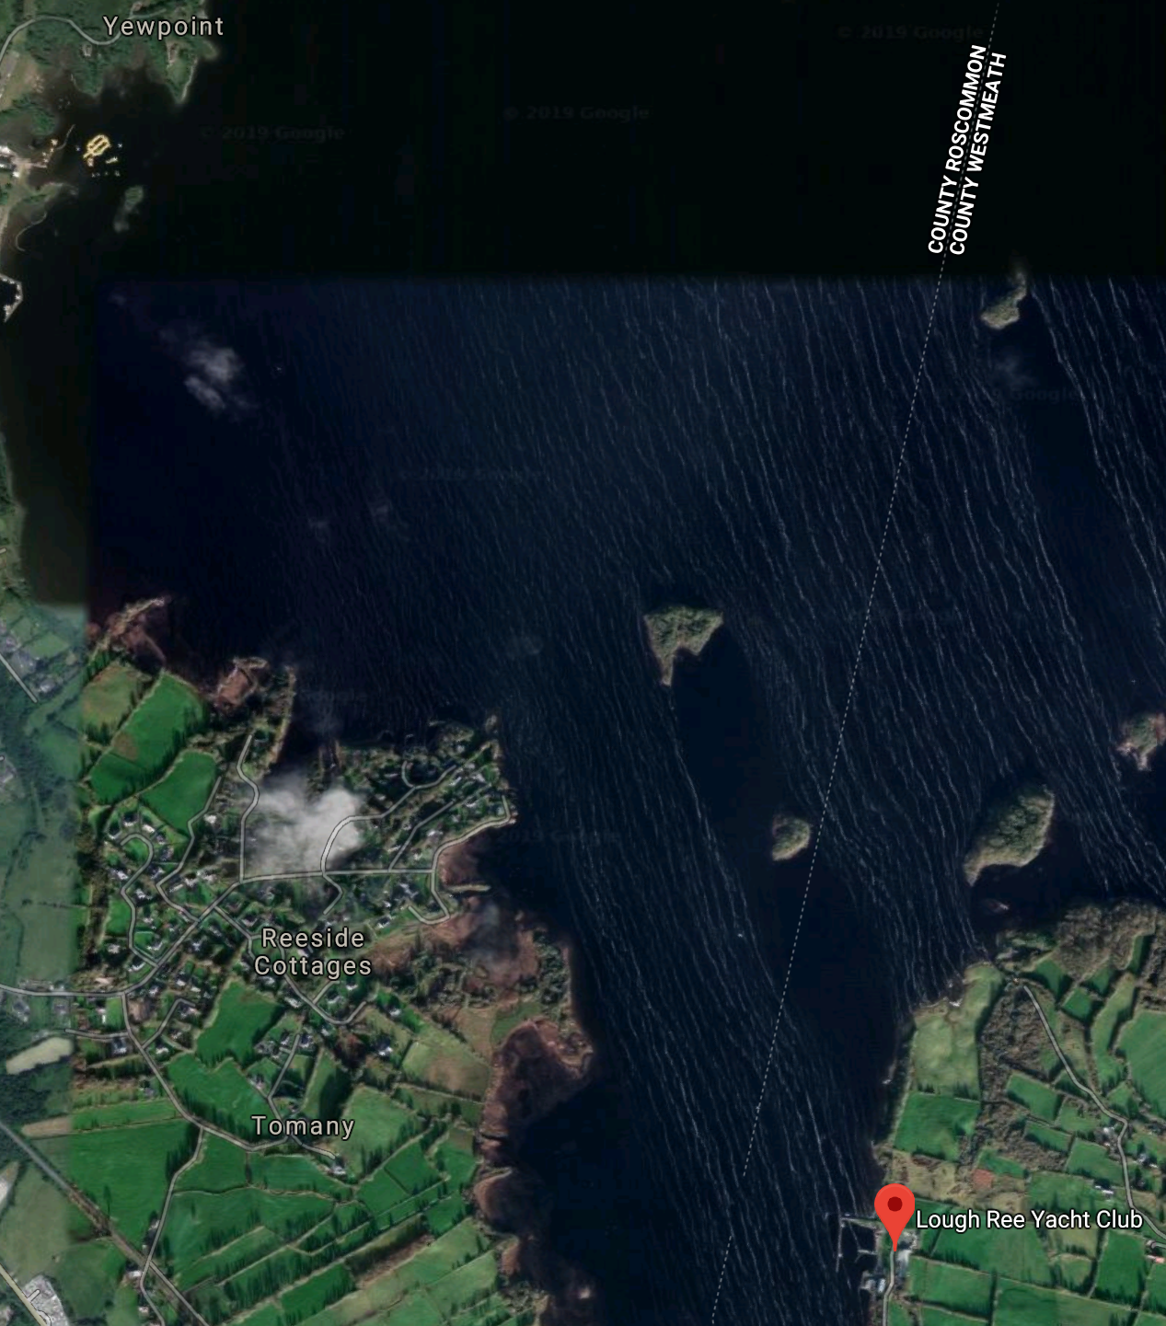

Approximate race area