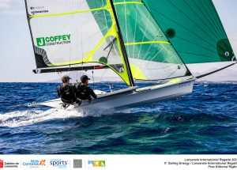

49er & 49erFX
Irish Inaugural Event

The Organising Authority (OA) is
Lough Ree Yacht Club (LRYC)
Ballyglass, Hillquarter, Coosan, Athlone, N37 K257

Sat 1st & Sun 2nd July 2023

NOTICE OF RACE (NoR)

The notation ‘[NP]’ in a rule means that a boat may not protest another boat for breaking that rule.
This changes RRS 60.1(a).

1 RULES

1.A The event will be governed by the rules as defined by The Racing Rules of Sailing (RRS).
1.B All relevant Class Rules will apply.

2 SAILING INSTRUCTIONS (SIs)

2.A The SIs will be available on or before Friday 30st June, on https://www.lryc.ie/event/ and on the event WhatsApp Group “49er & 49erFX Irish Inaugural Event LRYC.” (See NoR 3.A below)
Printed SIs will be available to competitors at registration.

2.B In the event of a conflict between this NoR and the SIs, the SIs will prevail.

3 COMMUNICATIONS

3.A Notices to competitors will be posted on the event WhatsApp Group and
may also be posted on the Notice Window situated at the front of the clubhouse.



3.B [DP] While racing, except in an emergency, a boat shall not make voice or data transmissions
and shall not receive voice or data communication that is not available to all boats.
This applies also to mobile telephones.

4 ELIGIBILITY & ENTRY

4.A The event is open to boats of the 49er & 49erFX classes.
4.B The Portsmouth Yardstick Handicap System (PY) will be applied to boats racing
as below:

Class | Handicap
49erFX | PY 720
49er | PY 697

These may be updated after the last race on Saturday.

4.C Eligible boats may enter the event by registering online by Sunday 25th June,2023.
at: 49er & 49erFX Irish Inaugural Event – Lough Ree Yacht Club (lryc.ie)

4.D Late entries will be accepted until Friday 30th June,2023.

5 FEES
5.A Entry fees are as follows:

Standard Fee | Late Entry Fee
€ 70.00 | € 80.00

6 CREW LIMITATIONS ---- Not Applicable at this event

7 ADVERTISING ---- Not Applicable at this event
8 QUALIFYING SERIES AND FINAL SERIES ---- Not Applicable at this event

9 SCHEDULE
9.A Registration:

Date | From | To
Saturday 1st July | 10.00 | 10.45

9.B The Competitors’ Briefing will take place in front of the clubhouse at 11.00.
9.C 7 (Seven)Races are scheduled as follows:

Date | Time of first Warning Signal | Number of Races Scheduled
Saturday 1st | 12.25 | Up to 4
Sunday 2nd | 10.10 | Remaining races to complete the Series

9.D The warning signal for each succeeding race will be made as soon as is practicable.
9.E On the last scheduled day of racing no warning signal will be made after 13.55.

swa10 EQUIPMENT INSPECTION
10.A Boats may be inspected at any time.

11 CLOTHING AND EQUIPMENT--- Not Applicable at this event.

12 VENUE

12.A NoR Addendum A shows the location of the The Racing Area which is approximately
two kilometres North of LRYC.

13 COURSES

13.A The courses will be of the Windward/ Leeward type and will be described in the SIs.

14 PENALTY SYSTEM

14.A RRS 44.1 and RRS P2.1 are changed so that the Two-Turns Penalty is replaced by
the One-Turn Penalty.

14.B In RRS 44.2 insert after the first sentence: “However, if Mark 1a is set, a boat
may take a penalty for an incident in the zone around Mark 1 or on the leg between
Mark 1 and Mark 1a, as soon as is possible after leaving the zone around Mark 1a”.

15 SCORING
15.A One race is required to be completed to constitute a series.

15.B Discards
(a) When fewer than 4 races have been completed, a boat’s series score will be the total of her race scores.
(b) When from 4 to 7 races have been completed, a boat’s series score will be the total of her race scores excluding her worst score.

16 SUPPORT PERSON VESSELS

16.A [DP] Support person vessels, if any, must register with the Race Committee.

17 CHARTERED OR LOANED BOATS --- Not Applicable at this event.

18 BERTHING --- Not Applicable at this event.

19 HAUL-OUT RESTRICTIONS --- Not Applicable at this event.

20 DIVING EQUIPMENT AND PLASTIC POOLS --- Not Applicable at this event.

21 DATA PROTECTION

21.A MEDIA RIGHTS. Competitors automatically grant to the OA, without payment, the right in perpetuity to make use of and show any motion pictures, still pictures and live, taped or filmed television of or relating to the event. This may include the use of unmanned aerial vehicles (drones) operated under IAA guidelines.

22 RISK STATEMENT
22.A RRS 3 states: ‘The responsibility for a boat’s decision to participate in a race or to continue to race is hers alone.’ By participating in this event each competitor agrees and acknowledges that sailing is a potentially dangerous activity with inherent risks. These risks include strong winds and rough seas, sudden changes in weather, failure of equipment, boat handling errors, poor seamanship by other boats, loss of balance on an unstable platform and fatigue resulting in increased risk of injury. Inherent in the sport of sailing is the risk of permanent, catastrophic injury or death by drowning, trauma, hypothermia or other causes.
22.B LRYC and any relevant Class Associations, etc., together with their officers, members, and volunteers, will not accept liability for the loss of life or property, or personal injury, or damage caused by or arising out of the event, including any pre-event training at the event site, and competitors take part in the event entirely at their own risk.

23 INSURANCE
23.A Each participating boat shall be insured with valid third-party liability insurance with a minimum cover of €3 M (three million euro) per incident, or the equivalent, valid for the entirety of the Event.

24 PRIZES
24.A Prizes will be given for 1st 2nd & 3rd overall. Other prizes may be presented.
24.B Prizegiving will be held as soon as is practicable after racing.

25 FURTHER INFORMATION
25.A For further information please contact John McGonigle at john@chronolab.net or (087) 979 1154

Addendum A INTENDED RACE AREA
approximately 2 kilometres North of LRYC.

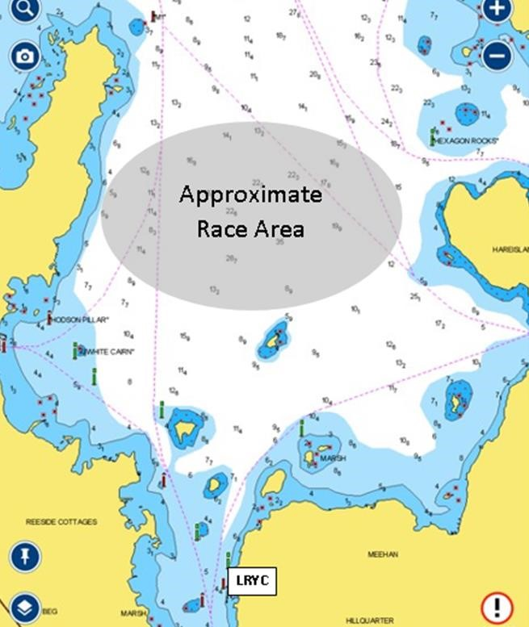

END OF NoR

OTHER INFORMATION

CATERING
- On Saturday evening there will be a Bring Your Own BBQ where a plate of salads can be purchased at a cost of 5 Euro - this can be done at registration.
- Please note the main kitchen will not be available but the Instructors Kitchen (limited facilities) will be.
- The Club barbecues Gas /Coal may be used.
- Electrical sockets are available for boiling kettles etc.

CAMPING
- Camping will be available at the club at no charge. Please treat the area with respect and please ensure all material is removed when leaving.

